

Kieron Townsend
Name:

229062747

Student No:

Impact of a Jet Experiment

Marks (for staff/TA use only)
Signature: _____________ | 0 - 5
Execution
Understanding

- Risk Assessment
Do not start until the demonstrator has explained the equipment to you.
Treat all equipment with care. A sudden application of the full jet on the lab apparatus may catapult the steel mass in use across the lab. This may cause injury.
- Overview: An application of the momentum equation
This experiment falls within the field of Fluid Mechanics. The objective of this experiment is to predict and measure the reaction forces produced by the change in momentum of a fluid flow.
  - Theory of forces on a surface from a jet of fluid
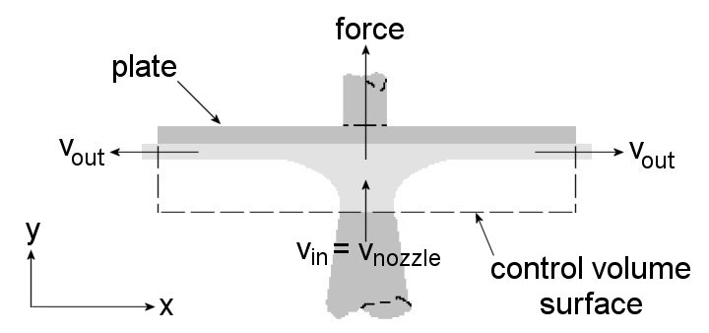
Fig. 1 shows a jet of water (light grey) from a nozzle impinging on a flat plate (dark grey). The water changes direction due to the presence of the plate which, by Newton's first law, means a force must be exerted on the water by the plate. By Newton's third law of motion the water must exert an equal and opposite force on the plate.
Figure 1 - Impact of a jet on a surface
Normally forces are obtained from:
$$F=ma=m\frac{dv}{dt}$$ | (1)
Where:
- $\frac{dv}{dt}$ is the rate of change in velocity (acceleration).
Since velocity is a vector, it will change if the object possessing it changes direction or speed. In Fig. 1, the jet changes direction which means its velocity will change but its speed may not.
$F=ma$ also requires a constant mass but in a fluid there is a mass flow rate (mass per unit time) which for any given measurement will be constant. Eq. (1) can be rewritten with $m$ and $v$ as time variables as follows:
$$F=\frac{d(mv)}{dt}$$ | (2)
Where:
- $mv$ is the momentum of the fluid, a product of the mass* of the fluid and its velocity
- The force, $F$, is the rate of change of momentum.
From Eq. (2) applied to a control volume as indicated in Fig. 1, $F$ can be expressed as:

$$F=\dot{m}(v_{in}-v_{out})$$ | (3)
Where:
- $F$ is the total applied force (N),
- $v_{in}$is the fluid velocity (m/s) of the flow when it enters into the control volume (also the velocity of the nozzle exit)
- $v_{out}$is the fluid velocity (m/s) of the flow when it exits into the control volume
- $\dot{m}$ is the mass flow rate of the fluid (kg/s)
Based on Fig. 1, Eq. (3) must be applied either vertically (y direction) or horizontally (x direction) which means only the components of force and velocity, the vectors, in the chosen direction need considering. This apparatus only measures forces in the y direction so only the component of velocity in the y direction needs considering in Eq. (3).
The following assumptions are necessary:
- The flow enters in the y direction only.
- The flow leaves the flat plate in the x direction only.
- The flow leaves the cup in the y direction only but in the opposite direction to entry.
- The magnitude of the velocity does not change through the plate or cup.
Little can be done about the first three assumptions but the fourth could be accounted for using one of the three equations of uniformly accelerated motion:
$$v^{2}=u^{2}+2as$$ | (4)
Where:
- $v$ is the fluid velocity as it strikes the plate (m/s) - as used in Eq. (3) above
- $u$ is the fluid velocity as it leaves the nozzle (m/s)
- $a$ is the uniform acceleration the fluid suffers after leaving the jet ($-g = -9.806m/s^{2}$)
- $s$ is the vertical distance from the top of the nozzle to the surface (35mm)
Since $a$ and $s$ are constant in this experiment, it can be seen that a constant value will be subtracted from $u^{2}$ to obtain $v^{2}$. This is not considered further in this experiment but should be in the analysis of results.
  - What needs to be done
- Measure the forces on a flat plate and a hemispherical cup with a jet of water striking them at several flow rates
- Apply the Momentum equation to the surfaces and determine how well it predicts the forces measured from the experiment.
- Suggest any means the arrangement of the apparatus could prevent the theory predicting the forces - i.e. by introducing something it doesn't predict.
- Take into account uncertainties in readings in the final results.
  - Apparatus
A beam with a fulcrum at its left end is held in a horizontal position using a spring and a mass. The flat plate or hemispherical cup are suspended below the beam at the top of a clear sided cylinder. A vertical nozzle is directly below the centre of the plate/hemisphere and is used to direct a jet of water at the surface at several discrete flow rates.
The force the jet produces on the surface is counteracted by moving a jockey weight along the beam. Jokey masses of either 200g, 400g or 600g are provided. How far the weight moves to bring the beam back to the horizontal is a measure of the force of the jet and a ruler is attached to the beam to measure it. The zero on the ruler is vertically in line with the axis of the plate/cup and the nozzle. The flow rate of the jet is adjusted by using a tap in the base unit below the table the apparatus rests on and can be read from the display to the left of the tap. Use the left side display in litres/second.
    - Controls
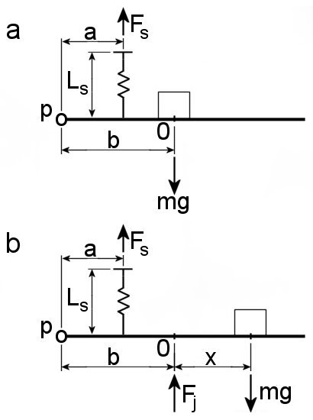
- The only control is the tap for adjusting the rate of flow.
    - Instruments
- The ruler to measure the position of the jockey weight
- The flow meter readout
    - Water jet force measurement system
The force of the jet on the cup or plate is measured indirectly using a spring loaded pivoted beam and a jockey mass which can be placed at any position along the beam. Figure 2a shows the beam in balance with no jet applied.
‘p’ is the pivot point (assumed frictionless) and ‘o’ is the 0 on the scale
Figure 2 - Moment diagrams
which coincides with the point of action of the jet when it is applied. In Fig. 2a the jockey mass is over point ‘o’.
The weight of the mass attempts to turn the beam clockwise. To prevent this, a spring pulls against it with a force $F_{s}$ to keep the beam horizontal. ‘a’ and ‘b’ are the distances from the pivot point to the points where the two forces act and can be used to form an equation of moments for this system. b is 0.15 m.
When the jet is applied (Fig. 2b) its force $F_{j}$ will turn the beam anticlockwise so the mass has to be moved further from the pivot point to restore the balance of moments and keep the beam horizontal. Will the spring force be different from Fig. 2a with the jet applied and the beam still horizontal?
A marked peg passing through the lid of the glass cylinder is used to set the initial horizontal level of the beam and to ensure it returns to the horizontal when the jet is applied.
The moment balance equations for Fig. 2a (5) and 2b (6) are given as:
$$F_{s}×a=mg×b$$ | (5)
$$(F_{s}×a)+(F_{j}×b)=mg×(b+x)$$ | (6)
  - Method of Analysis
The tap will be used to control the flow of water to several discrete values.
At each discrete value the flow rate and jockey position will be recorded in the Impact of a Jet Data Table along with an estimation of the uncertainties in their values. You are to plot graphs as data is being collected which will help determine where to next take data and if any gaps need filling.
    - Implementation of method
The jockey mass position is a measure of the force applied by the jet and is proportional to the flow rate. To obtain the characteristic of the proportionality (linear, logarithmic, etc.), the flow rate will be plotted on the x axis and the force on the y axis for several flow rates. The maximum flow that can be achieved is determined when the jet makes the beam horizontal with the mass as far top right on the ruler scale as it can be or when the tap is fully open and the beam has not become horizontal (in which case the mass must be moved to the left until the beam becomes level).
- The first step is to place the correct jockey weight for the model over the zero of the ruler with no flow present. Adjust the screw above the spring to bring the marker at the free end of the beam in line with the lid of the cylinder. This ensures the beam is horizontal at the start of the experiment.
- Now place the mass as far to the right as it can go and open the tap until the beam balances. If it does not balance, leave the flow at maximum and move the mass to the left until it does balance.
- Since the checks above require the apparatus to be at its highest flow, record data at points descending from it.
- In order to get a plot of force against flow, set the flow so the beam is not balanced and move the mass to make it balance.
Assuming the flow is set and the mass is positioned afterwards, if the highest flow is 0.5litre/s and a minimum of eight points are thought necessary to plot a good graph, then changing the flow by 0.05l/s should produce enough points. The meter, reading to 3dp, will allow this.
Do not be afraid to have a play with the apparatus as knowledge gained by doing so can make for a better procedure. However, please treat all equipment with respect or it can bite - for instance gradual changes in an input you apply will usually produce gradual changes in output. The opposite is also usually true: suddenly applying the full jet on this apparatus may catapult the steel mass across the lab – this could cause injury to someone or damage to an equipment.
  - Tasks
Generally, your task is to:
- Carry out the experiment and fill in the required data into the tables.
- Complete the analysis by answering the provided questions
- Plot the related graphs on the graph paper or in chosen plotting software (for example Excel).
Note:
- Graphs must be neatly plotted.
- Axes must be correctly labelled.
- Since a number of signals are being plotted together in each graph, neatly label each signal on the graph at the end of its last value to the right, so it can be easily identified by the marker (or anyone looking at or assessing your work). Suggested signal names/identifiers can be$Plate$ and$Cup$.
Specifically, the following instructions apply:
- Record flow rate ($Q$), jockey position ($x$) and mass flow rate ($\dot{m}$) in Tables 1 and 2 below for respectively plate and cup data. Note the following:
  - $\dot{m}=ρQ$ where water density ($ρ$) is $997kg/m^{3}$
- $Q$ is in litres/sec while $\dot{m}$ should be in kg/s which means $\dot{m} \left[\frac{kg}{s}\right]=\frac{ρQ}{1000}$
- How much does the jockey position ($x$) have to be changed before a change in level can be detected? Record this interval as $x_{err}$ in Tables 1 and 2. The interval is the jockey position when the change in level is detected$x_{change}$, relative to$x$ i.e. $x_{err}=\left|x_{change}-x\right|$
- Answer the following:
- Combine equations in (5) and (6) into a single equation that can be used to calculate the jet force${ F}_{meas}=F_{j}$ from the jockey position ($x$).
- Rewrite the equation derived in iii, replacing “$F_{meas}$” and “$x$” with “${F_{meas}}_{err}$” and “$x_{err}$” respectively.
- Using the equations in iii and iv above, calculate and note the measured force $F_{meas}$ for each jockey position (x) and ${F_{meas}}_{err}$ for each $x_{err}$ in Tables 1 and 2
- Plot $\dot{m}$ (x-axis) against ${ F}_{meas}$ (y-axis) for Plate Data and for Cup Data on the same Graph A below.
- Is the relationship between force and mass flow rate linear or not?
- Given that $\dot{m}=ρQ$ and $Q=Av$, obtain an equation for $v$ in terms of $\dot{m}$.
- Fig. 1 shows for the configuration for the Plate, sketch the configuration for the Cup.
- Substitute your equation from page 8 question 10 vi ($F_{meas})$. above into Eqn. (3) (show working in section below) to derive $F_{theor}$ as a function of$\dot{m}$, with the assumptions listed in the theory section.
Note: The equations you will derive will differ for the plate and the cup because of$v_{out}$.
- What is the relationship between $F_{theor}$ and $\dot{m}$? Is this relationship satisfied in the plots of $F_{meas}$ in Graph A?
- From your derived equation above, calculate and note $F_{theor}$ in Tables 1 and 2.
- Plot $F_{theor}$ (x-axis) against $F_{meas}$ (y-axis) for the Plate configuration in Graph B and for the Cup configuration in Graph C.
- For each data point on a graph, add error bars.
- For each graph, draw a straight line from the top of the error bar at one extreme to the bottom of the error bar at the other extreme, and vice versa (forms a sort of x-shape of 2 straight lines on each graph, this can also be done with plotting software).
- The plot of Graph B should be a straight line. Obtain the gradients for the lines of best fit in graphs B and C. (Remember, each graph has 2 lines of best fit!) Note: If the theory is followed precisely, the gradient would be 1 with an intercept of 0,0.
- What effects (if any) does each of the assumptions listed in the theory section have on your results?
- Is the theoretical force ($F_{theor}$) higher or lower than the measured force ($F_{meas}$) because of these assumptions?

- Other Comments or Thoughts or Observations
There is space below for you to add any comments regarding this lab, a suggestion for improvement, an idea perhaps to be explored further, an observation, etc.

- Results, Analysis, and Discussion
Record flow rate ($Q$), jockey position ($x$) and mass flow rate ($\dot{m}$) in Tables 1 and 2 below for each respective setup (Plate and Cup):
Table 1 - Plate Data
Plate m (mass used in measuring system, kg) =
$$Q [l/s]$$ | $$\dot{m} [kg/s]$$ | $$F_{theor} [N]$$ | $$x [mm]$$ | $$x_{err} [±mm]$$ | $$F_{meas} [N]$$ | $${F_{meas}}_{err} [±N]$$
0.50 | 0.4985 | 3.15 | 109.00 | 20.50 | 2.85 | 0.54
0.45 | 0.4487 | 2.55 | 89.50 | 11.00 | 2.34 | 0.29
0.40 | 0.3988 | 2.01 | 78.50 | 11.00 | 2.05 | 0.65
0.35 | 0.3490 | 1.53 | 53.50 | 14.50 | 1.40 | 0.38
0.30 | 0.2991 | 1.12 | 39.00 | 17.00 | 1.02 | 0.44
0.25 | 0.2493 | 0.77 | 22.00 | 9.50 | 0.58 | 0.25
0.20 | 0.1994 | 0.48 | 12.50 | 3.50 | 0.33 | 0.09
0.15 | 0.1496 | 0.26 | 12.50 | 9.00 | 0.24 | 0.24

Table 2 – Cup Data
Cup m (mass used in measuring system, kg) =
$$Q [l/s]$$ | $$\dot{m} [kg/s]$$ | $$F_{theor} [N]$$ | $$x [mm]$$ | $$x_{err} [±mm]$$ | $$F_{meas} [N]$$ | $${F_{meas}}_{err} [±N]$$
0.50 | 0.4985 | 6.30 | 144.0 | 29.00 | 5.65 | 0.76
0.45 | 0.4487 | 5.09 | 115.00 | 23.50 | 3.01 | 0.61
0.40 | 0.3988 | 4.01 | 91.50 | 23.50 | 2.39 | 0.61
0.35 | 0.3490 | 3.06 | 68.00 | 16.50 | 1.78 | 0.43
0.30 | 0.2991 | 2.23 | 51.50 | 20.50 | 1.35 | 0.54
0.25 | 0.2493 | 1.53 | 31.00 | 11.50 | 0.81 | 0.30
0.20 | 0.1994 | 0.96 | 19.50 | 15.00 | 0.51 | 0.39
0.15 | 0.1496 | 0.52 | 4.50 | 4.50 | 0.12 | 0.12

Experimental Findings
- Answer the following:
- Combine equations in the moment balance equations in (5) and (6) above into a single equation that can be used to calculate the jet force${ F}_{meas}$ from the jockey position ($x$).

- Rewrite the equation derived in iii, replacing “$F_{meas}$” and “$x$” with “${F_{meas}}_{err}$” and “$x_{err}$” respectively.

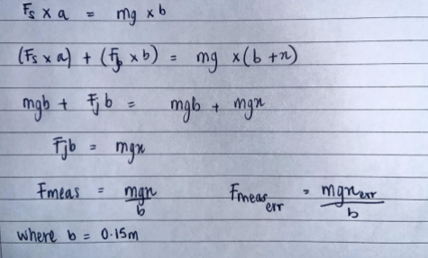

- Using the equations in iii and iv above, calculate and note the measured force $F_{meas}$ for each jockey position (x) and ${F_{meas}}_{err}$ for each $x_{err}$ in Tables 1 and 2
- Plot $\dot{m}$ (x-axis) against ${ F}_{meas}$ (y-axis) for Plate Data and for Cup Data on the same Graph A below (graph can be plotted using plotting software like Excel).

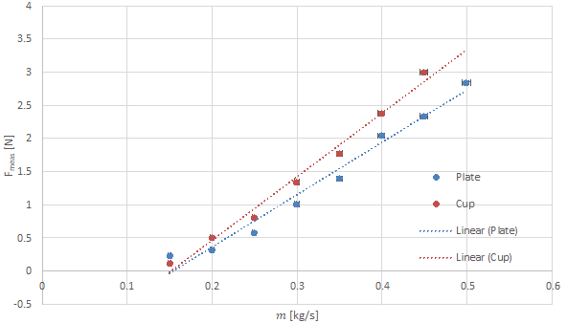

Graph A: Mass Flow rate in Kg/s against Fmeas in N

Discussion
- Is the relationship between force ($F_{meas}$) and mass flow rate ($\dot{m}$) linear or not?

There is a linear relationship between Fmeas and mass flow rate as the mass flow rate increases the Fmeas increases always to highlight their linear relationship

- Given that $\dot{m}=ρQ$ and$Q=Av_{in}$, obtain an equation for $v_{in}$ in terms of$\dot{m}$.
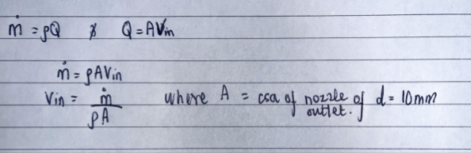

- Fig. 1 shows the configuration for the Plate, sketch the configuration for the Cup below:

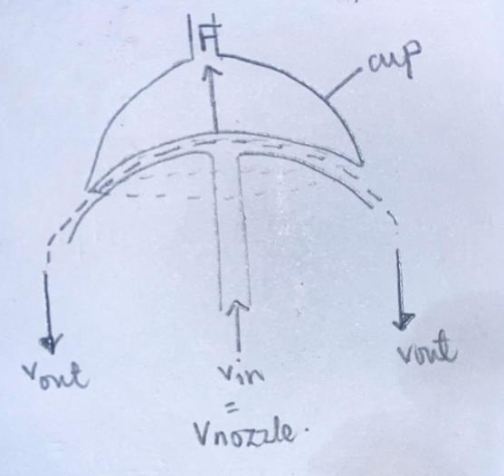

- Substitute your equation from page 8 question 10 vi ($F_{meas})$ above into Eqn. (3) (show working) to derive $F_{theor}$ as a function of$\dot{m}$, with the assumptions listed in the theory section.
Note: The equations you will derive will differ for the plate and the cup because of$v_{out}$. You should not have Q in your final equation (It is fine along the way).

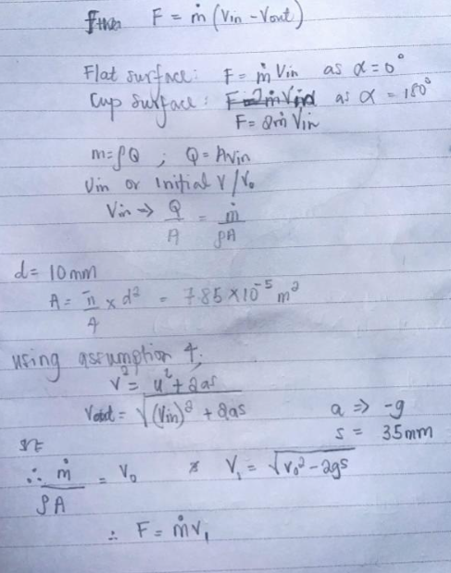

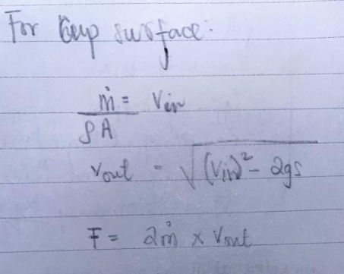

- What is the relationship between $F_{theor}$ and $\dot{m}$? Is this relationship satisfied in the plots of $F_{meas}$ in Graph A?

The relationship between Ftheor and mass flow rate has the same linearity of the relationship between Fmeas and m in Graph A.

- From your derived equation above, calculate and note $F_{theor}$ in Tables 1 and 2.

- Plot$F_{theor}$ (x-axis) against $F_{meas}$ (y-axis) for the Plate configuration in Graph B and for the Cup configuration in Graph C. For each data point on a graph, add error bars. For each graph, draw a straight line from the top of the error bar at one extreme to the bottom of the error bar at the other extreme, and vice versa (forms a sort of x-shape of 2 straight lines on each graph, can also be done with plotting software).

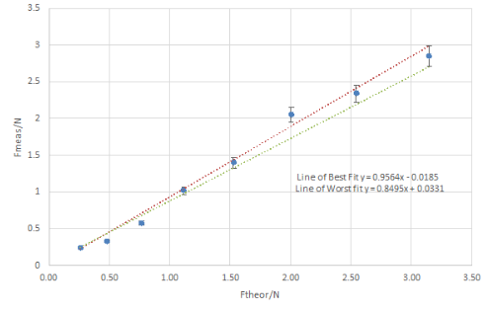

Graph B (Plate)
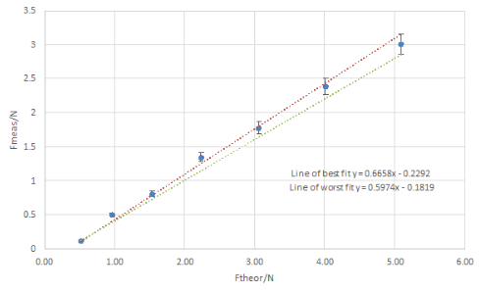

Graph C (Cup)

- The plot of Graph B should be a straight line. Obtain the gradients for the lines of best fit in graphs B and C. (Remember, each graph has 2 lines of best fit!)
Note: If the theory is followed precisely, the gradient would be 1 with an intercept of 0,0.

- What effects (if any) does each of the assumptions listed in the theory section have on your results?

The flow solely enters in the y direction:
This assumption implies that the fluid flow does not have any component in the x-direction upon entering the system. Any deviation from this assumption, such as a small component in the x-direction, could affect the overall momentum balance and thus impact the calculated force.

The flow exclusively leaves the flat plate in the x direction:
This assumption suggests that the fluid flow departs from the plate solely in the x-direction. Any deviation from this assumption, such as flow departing in other directions, could lead to inaccuracies in the calculated force due to a misalignment between the assumed direction of flow and the actual flow direction.

The flow solely exits the cup in the y direction, but in the opposite direction to entry:
This assumption indicates that the fluid leaves the cup solely in the y-direction but in the opposite direction to its entry. Any deviation from this assumption, such as flow exiting in directions other than the y-direction or not being opposite to the entry direction, could introduce errors in the force calculation.

The magnitude of the velocity remains constant through the plate or cup:
This assumption assumes that there is no change in the magnitude of velocity as the fluid flows through the plate or cup. However, in real-world scenarios, there might be variations in velocity due to factors like friction, turbulence, or other flow characteristics. Ignoring these changes could lead to inaccuracies in the calculated force.

- Is the theoretical force ($F_{theor}$) higher or lower than the measured force ($F_{meas}$) because of these assumptions?

- Assumption of Constant Velocity Magnitude: By presuming that the velocity magnitude remains unchanged through the plate or cup, the theoretical model could overstate the actual velocity experienced by the fluid. This assumption may result in a higher theoretical force calculation since it neglects any losses or alterations in velocity magnitude caused by factors such as friction, turbulence, or other flow characteristics. In practice, these factors can diminish the velocity magnitude, thereby yielding a lower measured force compared to the theoretical prediction.

- Simplifications in Flow Directions: The assumptions concerning the flow's entry and exit in specific directions (e.g., solely in the y-direction) might oversimplify the actual flow dynamics. The flow may exhibit components in multiple directions or may not precisely align with the assumed directions. Any deviation from these assumptions can induce disparities between the theoretical and measured forces, potentially resulting in an overestimation of the force by the theoretical model.

Other Thoughts/Comments/Observations:

The errors involved in the calculations are less than 5% in all comparisons between the theoretical force (F_theor) and the measured force (F_meas). This indicates a robust relationship and suggests that the results are reliable for consideration.

Ways to enhance this experiment:

- Reduce experimental error by meticulously calibrating instruments, ensuring proper setup, and controlling environmental factors such as temperature and pressure. Conducting multiple trials and averaging the results can also diminish random errors.

- Adjust assumptions to better align with real-world flow conditions. For example, consider the three-dimensional nature of fluid flow and consider velocity changes caused by factors such as viscosity, turbulence, and boundary effects.

- Employ Computational Fluid Dynamics (CFD) simulations to model fluid flow behaviour more accurately. CFD enables a thorough analysis of flow dynamics, incorporating aspects like turbulence and boundary layer effects that might not be captured in simplified theoretical models.

- Validate experimental findings by comparing them with theoretical predictions, numerical simulations, or experimental data from other sources. Consistency across different validation methods can bolster confidence in the experimental results.

